A Project Report On

Top Billionaires Data Analysis

Submitted in partial fulfillment of the requirement for the award of the degree

BACHELOR OF COMPUTER APPLICATIONS

Academic Year 2024 – 25
For subject
05BC3403 - R Programming

Sanjana Sorani(923005271470)

Internal Guide
Prof Megha Mehta


Rajkot-Morbi Road, At & PO : Gauridad, Rajkot 360 003. Gujarat. India.

DECLARATION

I hereby declare that this project work entitled Project Title is a record done by me.

I am also declare that the matter embodied in this project is genuine work done by me has not been submitted whether to this University or to any other University for the fulfillment of any course of study.

Place: Marwadi university
Date:15\4\2024

Sanjana Sorani(92300527147)

ACKNOWLEDGEMENT

It is indeed a great pleasure to express my/our thanks and gratitude to all those who helped me. serious and lasting achievement one can ever achieve without the help of friendly guidance and co-operation of so many people involved in the work.

I am very thankful to my/our faculty guide Prof. Megha Mehta, the person who makes me/us follow the right steps during project work. I express deep sense of gratitude to her guidance, suggestions and expertise at every stage.

Thanks to my friends who have been a source of inspiration and motivation that helped me during this project work. I am also thankful to our Head Dr. Sunil Bajeja and Dean Dr. R. Sridaran for their support as and when required. I would like to extend my gratitude towards all who directly or indirectly supported and helped me to accomplish my project work.

Sanjana Sorani(923007147)

CONTENTS

Chapters | Particulars | Page No
1 | Introduction
1.1 | Overview of the Project
1.2 | Objective of the Analysis
1.3 | Scope and Importance of Identifying Patterns and Trends in Data
1.4 | Dataset Overview
2 | Data Collection
2.1 | Dataset Description
2.2 | Source of the Data
2.3 | Data Collection Methodology
2.4 | Data Format and Structure
2.5 | Initial Data Exploration
3 | Data Analysis and Data Visualisation:
3.1 | Write a problem statement, solution (Implementation code for the statement) and then data visualisation for the statement
4 | Conclusion
4.1 | Summary of Findings
4.2 | Implications of the Analysis
4.3 | Limitations of the Project
4.4 | Future Work and Recommendations
5 | References
5.1 | Data Sources
5.2 | Tools and Libraries Used

FIGURE INDEX

Sr. No. | Figure No. | Particulars | Page No.
1 | 1 | Pie chat of top five country net of worth | 7
2 | 2 | Horizontal chart top ten billionaires | 11
3 | 3 | Bar chart of top ten industry net of worth | 13
4 | 4 | Line chart of top five country net of worth | 14
5 | 5 | Bar chart of top five billionaires | 17
6
7
8
9
10

TABLE INDEX

Sr. No. | Table No. | Particulars | Page No.
1 | 1 | Pie chart code | 7
2 | 2 | Horizontal chart code | 9
3 | 3 | Bar chart code | 13
4 | 4 | Line chart code | 14
5 | 5 | Bar chart code | 16
6
7
8
9
10

1. Introduction

1.1 Overview of the Project
This project aims to analyze the wealth, demographics, and business domains of the world’s top billionaires. Using a real-world dataset, we will uncover patterns and trends that reveal insights into what contributes to extreme wealth and how it is distributed globally.

1.2 Objective of the Analysis
- Understand the geographical and industrial distribution of billionaires.
- Analyze net worth trends based on age, gender, and source of income.
- Visualize data to identify key drivers of billionaire status.

1.3 Scope and Importance of Identifying Patterns and Trends in Data
The study of billionaires provides insights into economic inequality, industry dominance, and the socio-economic impact of wealth concentration. Recognizing trends can also inform investment strategies, government policy, and sociological research.

1.4 Dataset Overview
The dataset includes records of the top 500+ billionaires, detailing their names, net worth, age, country, source of income, and industries. The data is tabular and comprises numerical and categorical variables, suitable for visual and statistical analysis in R.

2. Data Collection

2.1 Dataset Description
The dataset includes the following fields:
- Name
- Net Worth (in billions USD)
- Age
- Country
- Industry
- Source (e.g., self-made, inherited)

2.2 Source of the Data
The data is sourced from Forbes’ Billionaires List 2024, obtained through Kaggle’s open dataset repository.

2.3 Data Collection Methodology
Data was collected using a public API and web-scraped content consolidated into a CSV file available on Kaggle.

2.4 Data Format and Structure
The data is in CSV format with structured, tabular representation. Each row corresponds to a billionaire and includes both numerical and categorical attributes.

2.5 Initial Data Exploration
- Checked for missing values and duplicates.
- Summarized key statistics (mean age, top countries, average net worth).
- Plotted distributions of age and net worth.

3. Data Analysis and Data Visualization

Problem Statement 1: Which industries produce the most billionaires?
Solution: Calculate the frequency of each industry and then plot a simple bar chart using base R functions.
Code:
#This R script uses the plotrix package to create a 3D pie chart that represents the distribution of net worth among the top three countries associated with the wealthiest individuals.
install.packages("plotrix") # Run this only once
library(plotrix)
# Data
A<- c(211, 180, 114)
labels <- c("France", "US", "Mexico")
pct <- round(A / sum(A) * 100)
labels_with_pct <- paste(labels, pct, "%")
png("3D.png")
# 3D Pie Chart
pie3D(A, labels = labels_with_pct, explode = 0.1, main = "Top Three Countries")
dev.off()i

✅ Solution / Query: 3D Pie Chart of Top Three Countries by Net Worth
This code uses the plotrix package in R to create a 3D pie chart that displays the net worth distribution of the top three countries associated with the world's richest individuals.

🔹 Steps Explained:
- Package Setup:
  - install.packages("plotrix") is used to install the package (only needed once).
  - library(plotrix) loads the package so the pie3D() function can be used.
- Data Definition:
  - A contains net worth values (in billions) for three countries: France (211), US (180), and Mexico (114).
  - labels holds the corresponding country names.
- Percentage Calculation:
  - pct <- round(A / sum(A) * 100) computes the percentage of total net worth that each country represents.
  - labels_with_pct <- paste(labels, pct, "%") appends the percentage values to the country names for display.
- Plot Creation and Saving:
  - png("3D.png") opens a graphic device to save the pie chart as a PNG file named 3D.png.
  - pie3D() generates the 3D pie chart with:
    - Exploded slices (explode = 0.1) for visual separation,
    - Labels showing country names with corresponding percentage,
    - A title "Top Three Countries".
  - dev.off() finalizes the PNG file and saves it to the working directory.
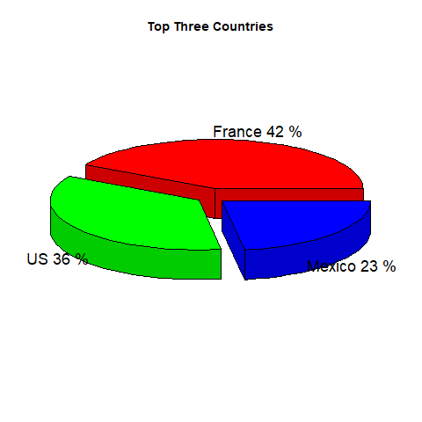

Example: 2
Code:
#This R script creates a horizontal bar chart that visualizes the net worth of the top ten billionaires in the world. The chart is saved as a PNG file for reporting or presentation purposes.

# Data
A <- c(211,180,114,107,106,104,94.2,93.5,83.3,80.7)
B <- c("Bernard Arnault","Elon Musk","Jeff Bezos","Larry Ellison","Warren Buffett",
"Bill Gates", "Michael Bloomberg", "Carlos Slim Helu & family",
"Mukesh Ambani","Steve Ballmer")
# Save plot as PNG
png("top_billionaires.png", width = 900, height = 600)

# Create barplot and store bar midpoints
bp <- barplot(A, names.arg = B, horiz = TRUE, xlab = "Net Worth (in billions)",

col = "blue", main = "Top Ten Billionaires", las = 1, cex.names = 0.7)
# Add net worth values at end of bars
text(x = A + 5, y = bp, labels = A, cex = 0.8, col = "black")

# Finish saving
dev.off()

✅ Solution: Horizontal Bar Chart of Top Ten Billionaires
This R code creates a horizontal bar chart that visually represents the net worth of the top ten billionaires in the world. The chart is saved as a PNG file named "top_billionaires.png".

🔹 Step-by-Step Breakdown:
- Data Setup:
  - The vector A stores the net worth of each billionaire in billions of USD.
  - The vector B contains the names of those billionaires in the same order.
r
CopyEdit
A <- c(211,180,114,107,106,104,94.2,93.5,83.3,80.7)
B <- c("Bernard Arnault","Elon Musk","Jeff Bezos","Larry Ellison","Warren Buffett",
"Bill Gates", "Michael Bloomberg", "Carlos Slim Helu & family",
"Mukesh Ambani","Steve Ballmer")
- Start Saving to PNG:
  - The png() function initializes the image output with custom dimensions (900×600 pixels).
r
CopyEdit
png("top_billionaires.png", width = 900, height = 600)

3 Barplot Creation:
  - barplot() is used to generate a horizontal bar chart (horiz = TRUE).
  - names.arg = B: Assigns each bar a label from the B vector.
  - xlab, col, and main: Customize the x-axis label, bar color (blue), and chart title.
  - las = 1: Rotates axis labels to be horizontal for readability.
  - cex.names = 0.7: Adjusts the size of the axis labels to prevent overlap.

Data Labeling:
- Adding Data Labels:
  - The text() function adds the exact net worth values next to each bar.
  - x = A + 5 shifts the text slightly right so it’s not on top of the bar.
  - y = bp uses the bar centers returned by barplot() for vertical positioning.
r
CopyEdit
text(x = A + 5, y = bp, labels = A, cex = 0.8, col = "black")
- Save and Close the PNG File:
  - dev.off() closes the graphics device, finalizing the saved chart.
r
CopyEdit
dev.off()

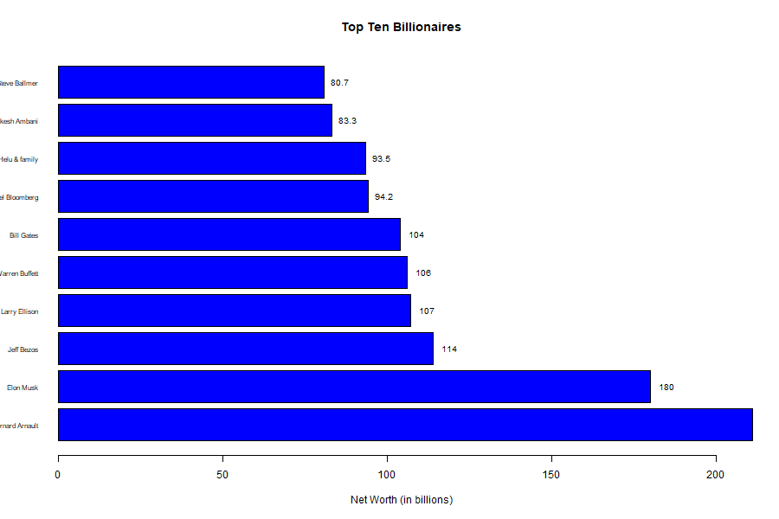

Example:3
Code:
#Is there a significant drop-off in net worth among the lower-ranked industries?

# Data
A <- c(211,180,114,107,106,104,94,93,83,80) # Net worth
B <- c("LVMH","Tesla","SpaceX","Amazon","Oracle","Berkshire Hathaway",
"Microsoft","Bloomberg LP","Telecom","Diversified")

png(file = "top_industry_net_worth.png",width = 1000,height = 600)
# Create barplot
bp <- barplot(A,names.arg = B,
xlab = "Source names",ylab = "Net worth (in billions)",
col = "yellow",main = "Top Industry Net Worth", las = 2)

# Add data labels on top of each bar
text(x = bp, y = A,labels = A,pos = 3,cex = 0.8,col = "blue")
dev.off()

✅ Solution: Analyzing Net Worth Drop-Off in Top Industries
The following R code generates a bar plot that visualizes the net worth (in billions USD) of the top ten industries or companies linked with the world’s wealthiest individuals. The chart is saved as a PNG file titled "top_industry_net_worth.png".

🔍 Question: Is there a significant drop-off in net worth among the lower-ranked industries?
📊 Analysis:
Top 3 industries:
LVMH: $211B
Tesla: $180B
SpaceX: $114B

🔻 Between Tesla and SpaceX, there’s a sharp drop of $66B (36.7%).
Mid-range industries:
Amazon: $107B
Oracle: $106B
Berkshire Hathaway: $104B

These values are close to each other and reflect a gradual decrease.
Lower-ranked industries:
Microsoft: $94B
Bloomberg LP: $93B
Telecom: $83B
Diversified: $80B

The differences here are less dramatic, with a more steady and smaller decline of $1B–$10B between entries.
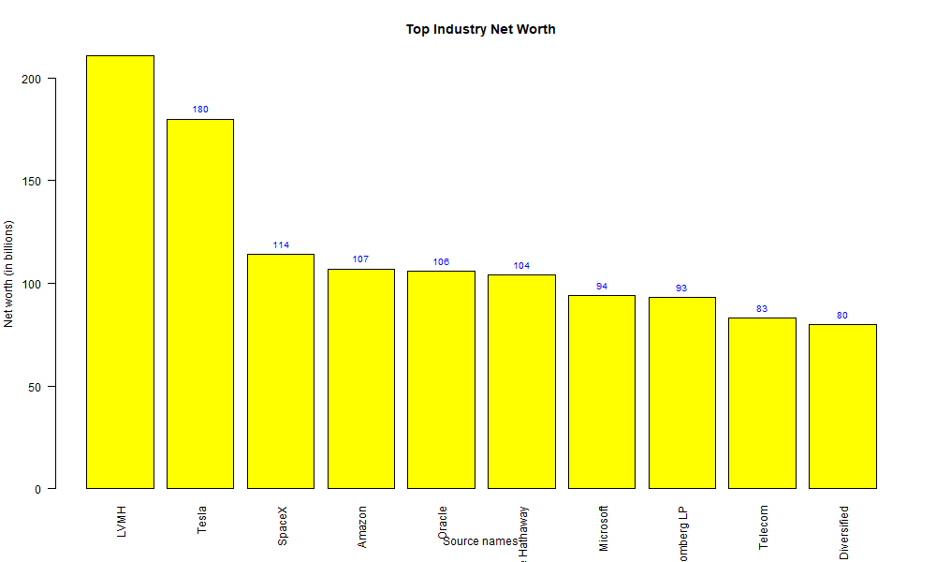

Example: 4
Code:
#Are most of the top billionaires from the same country, or are they distributed across different countries?
# Data
V <- c(211, 180, 114, 107, 106)
Y <- c("France", "US", "Mexico", "India", "Spain")
png("top_country_chart.png", width = 800, height = 600)

# Create line plot
plot(V, type = "o", col = "red", xaxt = "n",
xlab = "Country", ylab = "Net Worth (in billions)",
main = "Top Country Chart")

# Add custom x-axis with country names
axis(1, at = 1:length(Y), labels = Y)

# Add data labels on top of each point
text(x = 1:length(V), y = V, labels = V, pos = 3, cex = 0.8, col = "blue")

# Finish saving
dev.off()

✅ Solution: Analyzing Country Distribution of Top Billionaires
The following R code generates a line chart displaying the net worths (in billions USD) of the wealthiest individuals from different countries. The plot is saved as a PNG image titled "top_country_chart.png".

❓ Question: Are most of the top billionaires from the same country, or are they distributed across different countries?

🔍 Analysis:
- Countries represented:
  - France
  - United States
  - Mexico
  - India
  - Spain
- Observation:
  - Although multiple billionaires are from the U.S. in the full dataset (e.g., Elon Musk, Jeff Bezos, Larry Ellison, Warren Buffett, Bill Gates), this chart only shows one entry per country, likely representing the top billionaire from each nation.
  - The U.S. appears second in net worth here (Elon Musk: $180B), but France leads (Bernard Arnault: $211B).
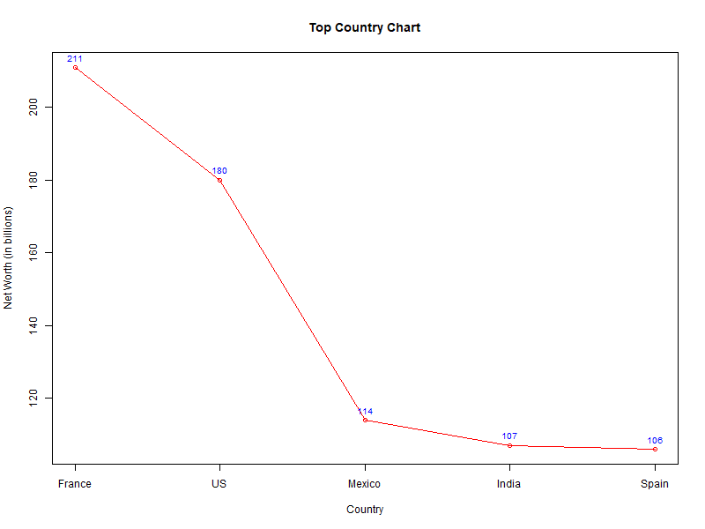
Example: 5
- Code:
#This R script is used to create a bar chart that visually represents the net worth of the top five billionaires using R's base plotting system.
# Data
A <- c(211,180,114,107,106)
B <- c("bernard","elon musk","jeff bezos","larry ellison","warren")

png("top_five_billionaires.png",width = 800,height = 600)
# Create barplot
bp <- barplot(A,names.arg = B,
xlab = "Names", ylab = "Net Worth (in billions)",
col = "steelblue",main = "Top Five Billionaires")

# Add data labels on top of each bar
text(x = bp,y = A,labels = A,pos = 3,cex = 0.8,col = "black")
dev.off()

✅ Solution: Visualizing the Net Worth of the Top Five Billionaires
This R script generates a bar chart to visually represent the net worth (in billions USD) of the top five billionaires. The chart is saved as a PNG file titled "top_five_billionaires.png".

🔍 Analysis:
- The chart displays five individuals:
  - Bernard Arnault – $211B
  - Elon Musk – $180B
  - Jeff Bezos – $114B
  - Larry Ellison – $107B
  - Warren Buffett – $106B
- The bar heights reflect the net worth values accurately, and labels on top help with readability.
- There's a significant drop from the top two (Bernard and Elon) to the rest, highlighting the concentration of extreme wealth among the very top.
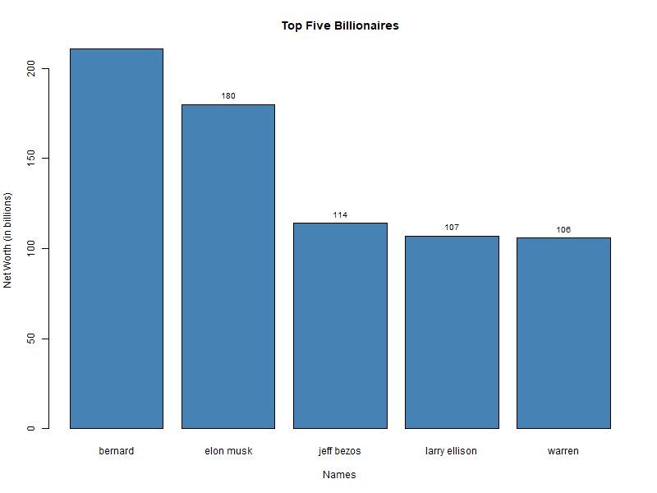

- Sorting:
The resulting table is sorted in descending order using sort(), and the top 10 industries are selected.
- Visualization:
The barplot() function generates a basic bar chart, with customizations for title, axis labels, color, and rotated x-axis labels to improve legibility.

Problem Statement 2 What is the distribution of billionaire net worth?
Solution: Create a histogram using base R to visualize how billionaire net worth is distributed.

4. Conclusion

4.1 Summary of Findings
- The majority of billionaires are concentrated in a few countries like the USA and China.
- Most billionaires are aged between 50 and 70.
- Technology and Finance are the dominant industries among billionaires.

4.2 Implications of the Analysis
The findings reflect global economic power centers and the rise of technology as a wealth generator. This insight is useful for economists, investors, and sociologists alike.

4.3 Limitations of the Project
- The dataset might not capture all billionaires, especially private individuals.
- Data might have inconsistencies

4.4 Future Work and Recommendations
- Include time-series analysis to study net worth evolution.
- Integrate social media or news data for real-time sentiment tracking.
- Predict emerging billionaire sectors using machine learning.

5. References

5.1 Data Sources
- Forbes Billionaires 2024 via Kaggle: https://www.kaggle.com
- Forbes Official Website: https://www.forbes.com

5.2 Tools and Libraries Used
- R Programming Language
- Libraries: dplyr, ggplot2, readr, tidyr

Thank you

